To: Individuals who are supported by the Services of the Brothers of Charity Services Ireland

How does change in Data Protection affect you?

Data Protection means that your personal information is stored properly
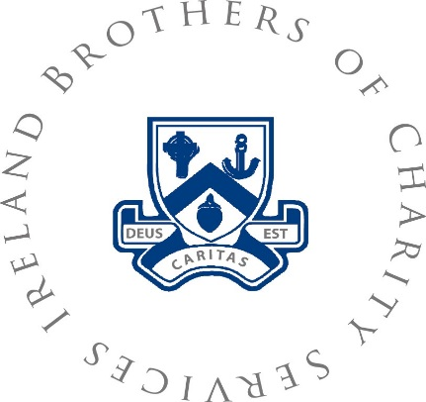  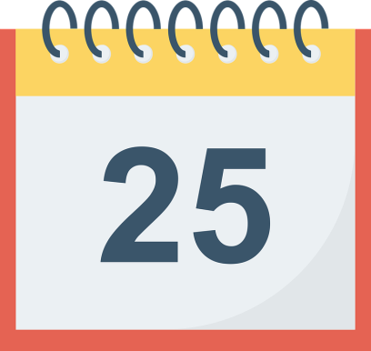 | On 25th May a new EU rule will come in to effect.  This is called the General Data Protection Regulation or GDPR  This is an update to the existing data protection law  It will make Organisations like the Brothers of Charity Services Ireland be more accountable  when using your information.  It will give you greater control over your information
The Brothers of Charity Services Ireland collects and keep personal information about you
This is to help us provide a good service

We use your information to do this

This information includes:

- Name
- Gender
- Date of birth

- Religion
- Address
- Phone numbers

- Next of Kin
- Medical history
- Behaviour Support Plans

- Financial details
- Multi-disciplinary Reports
- Dental and GP appointments

We must keep your information safe

Sometimes we may share your information with people. This is to make sure that we can give you the best service.

People we may share information with include

- Staff who work with you
- State Bodies who may need information
- Family members who you have said we can.
- Healthcare professionals
- The Hospital

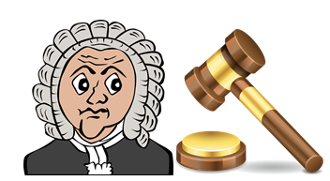 | We have your information because we want to give you services and supports.  The Data Protection law says the information must be up to date.
You can see the information about you if you want to. This is your right.

We must get back to you within 30 days of you asking

If we say no to giving you the information we must tell you why

If we say no and you are not happy with this you can contact the Data Protection Commissioner.

They will check what information we have

They will ask us why we said no.

If they don’t agree they will tell us to give you your information.
You should know:
That we have personal information about you
Why we have it
What we do with it

 | You have the right to ask questions about this.
 | If the Brothers of Charity Services Ireland wants to use your information outside of service delivery we must ask you first
You can contact the Data Protection Officer by email at gmagliocco@brothersofcharity.ie
or post at Kilcornan House,
Clarinbridge
Co Galway H91 K2E9

