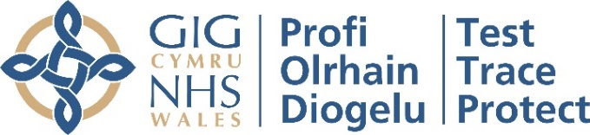

Dear X,
We are pleased to advise that we have now introduced Lateral Flow Testing (LFT) for visitors to our care home. This will enable our care home to offer regular testing for visitors, and when combined with other infection prevention and control measures (such as PPE, handwashing, appropriate social distancing), may in future enable us to support more meaningful visits with loved ones. We are determined to help care homes and families work together to find the right balance between the benefits of visiting on wellbeing and quality of life, and the risk of transmission of COVID-19 to social care staff and residents.
We will be testing one designated visitor per resident up to twice weekly (visitors will be tested each time they come for a visit).
When we refer to a ‘designated visitor’, we mean the family member or friend who will be the primary indoor visitor when local COVID-19 circumstances allow. This means the same visitor visiting each time to limit the number of different people entering the care home and reducing the consequent risk of infection.
A deputy may be identified to undertake indoor visits if the designated visitor is unable to visit, for example if they are unwell or away. However, the roles are not routinely interchangeable.
This letter sets out more about what the testing process will involve, what it will mean for you and the other precautions we ask that you take to keep your loved ones and all our residents and staff safe.
Do I have to be tested in order for me to visit my friend or relative?
It is not compulsory for you to be tested for your visit but if you are not tested it may affect how and when you can visit the care home. If you would prefer not to be tested, please do discuss this with our care home manager. Each care home will decide how best to manage visits based on clinical guidance on infection control and testing provided and they will be formally advised if visiting needs to be suspended due to COVID-19 incidents and outbreaks. The care home manager will be able to talk through possible options for visits. But please be aware that organised visits are at the care home’s discretion, and based on their assessment, the care home manager may advise that it might not be possible to facilitate visits with you at this time.
In the event of an outbreak in our care home, please note that visits will not be going ahead.

What does testing involve?
You will be asked to take a test using a new technology called a Lateral Flow Test (LFT). You will be tested as you arrive at the care home before visiting to check if you currently have COVID-19.

For this, we will ask you to do a throat and nose swab every time you visit and then we will let you know your result in 30 minutes. We will ask you to complete the swabbing yourself, supervised by a trained staff member. A swab is a small piece of soft, absorbent material on a plastic stick that is used to take a sample from your nose and throat.

The test is very straightforward and you will be supported throughout the process by a member of staff from the care home. Full instructions will be provided to you upon your scheduled visit.

Key steps you should be prepared for during the test include:

- When you first enter care home
- You will be provided with PPE and put it on as advised by a member of staff. This will include gloves, mask and apron. See the end of this letter for a pictorial guide on how to correctly put on and take off PPE. A staff member will help you with this.
- You will be asked to sign a consent form to take the test and share personal information with us so we can record and tell you your result.
- You will be checked in for your visit.

- You will then be asked to register for your test
- This is how we can link you to your test sample and result.
- This will be completed via an online form on an iPhone that we will provide.
- If you cannot complete this form yourself, a staff member can help you.
- To complete the registration form, our staff will provide you with:
  - Your test kit barcode -- used to track your individual test
  - The test site ID number -- used to link your test to the care home
  - Test registration card -- used to save a copy of your barcode for your personal records
- Please see the end of this letter for a pictorial guide on how to register your test kit.
- Remember our staff member will be trained to assist you with this if you are unsure or concerned.

- Take your test:
- After you have been checked in by the designated care home staff, you will be given a swab.
- You will then need to take your own throat and nose swab, supervised by one of our trained staff members. We will walk you through how to swab yourself which will only take about 30 seconds to do.
- Once you have handed over the swab, you will be asked to wait until your result is ready which will take approximately 30 minutes.

- What does my result mean?
We will tell you your result and NHS Wales Test, Trace, Protect will also send your result via SMS (text message) and/or the e-mail​ that you provided on the online registration form.
- Positive – you will not be able to visit. You will have to take a second, confirmatory PCR test (a different kind of throat and nasal swab test) which we will provide and register for you. You must go home immediately and you and your household will have to self-isolate. You will receive the result of your confirmatory PCR test in around 72 hours (you need to self-isolate until you get your result). If you test positive in the confirmatory PCR tests, NHS Wales Test, Trace, Protect may contact you to ask you for your contacts.
- Inconclusive – we will ask you to do another LFT test. If this is inconclusive too, we will discuss your visit with you.
- Negative – your visit will be able to go ahead, as long as you comply with all other infection prevention and control measures (see below). This does not guarantee that you definitely do not have Covid-19, so we still need to make sure visits take place in a safe way. If you have any questions about this, please do ask.

It’s important to recognise that a negative test will provide us with some assurance as to whether or not you are carrying the COVID-19 virus but it is not a guarantee. To keep your loved one and our care home safe, we ask that you please follow the below guidelines:
- Stay home if you are feeling unwell, including if you have a high temperature, a new continuous cough or a loss or change in your taste and smell.
- Follow national guidance outside of your visit, including limiting your contact with other people and wearing a mask in public if possible.
- Observe social distancing with anyone outside of your household or bubble and wash your hands regularly.

During your visit – Do’s and Don’ts
Inside the care home, we ask that you continue to wear your face covering/mask and any other PPE that you were asked to wear by a member of staff. Please continue to follow our visiting policy throughout the visit.
Other behaviours that are allowed during your visit:
- You will be allowed to enter the resident’s room if this will help improve access to the visit so long as you remain socially distanced and use PPE
Behaviours that are not allowed during your visit:
- Taking off any PPE according to guidance from the member of staff
- Entering into any part of the home that is not designated
- Close contact or touching any resident or member of staff
- Close contact including holding hands or visiting less than 2 meters apart with your friend or relative
- Bringing along food or treats to your resident
Thank you in advance for your patience and cooperation. We will continue to work hard to support and improve meaningful visits with our residents.
Yours sincerely,

[Name of care home manager]
Pictorial Guide – Self-swabbing instructions
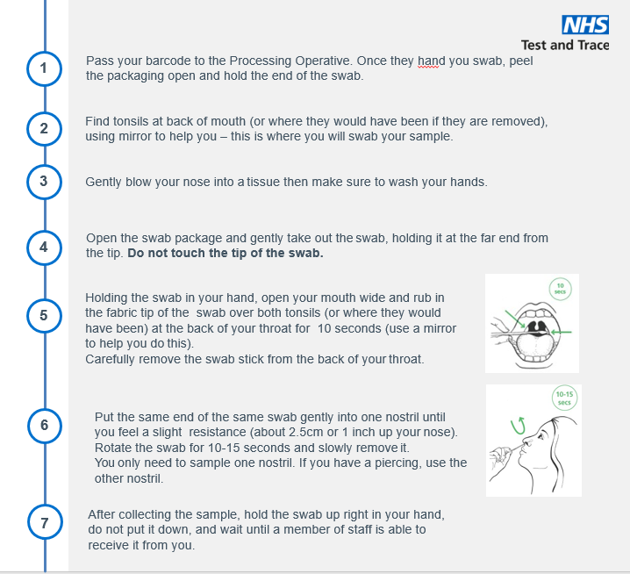
Pictorial Guide – Putting on and removing PPE

Pictorial Guide: Test Kit Registration

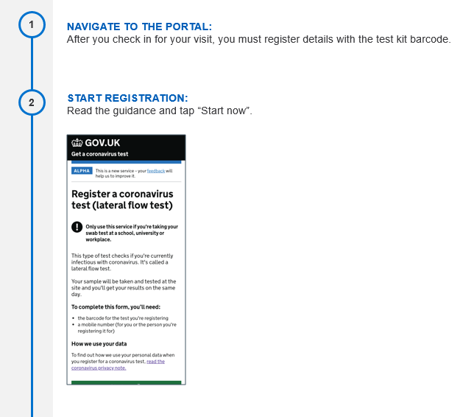
gov.uk/enter-lateral-flow-test

