Date:
Lenovo Yoga Tablet
This is a tablet from Your Voice Counts for you
to borrow for 3 months until 12/08/2020
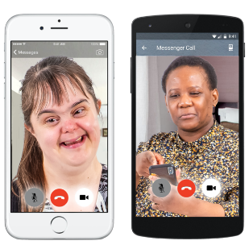 | We are loaning it to you so that you can join in with Your Voice Counts online groups.  You can also use it to stay in touch with your friends on Skype, text or by calling them.
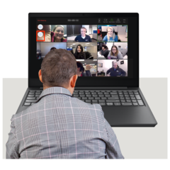 | The tablet will use the WiFi signal where you live so you can access the internet.
 | Please look after it, we cannot replace it if it is damaged, lost or broken.
 | The tablet is just for you to use, please do not give it other people to use or take away or sell it. Your Voice Counts may take action if the phone is sold.
 | We will help you to understand how to use it. If you want help, please ask ……. to help you. Her phone number is:
We have set the phone up so you can use:
WhatsApp

Skype

Email

Zoom

 | If you would like to add or take away things let us know.
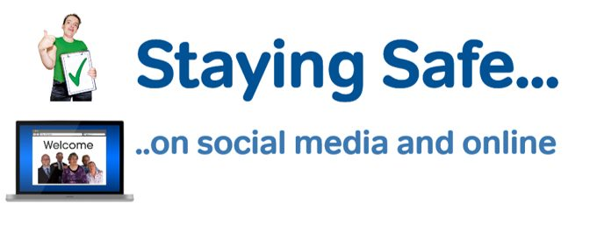 | We want you to feel safe being on the internet. We will help you understand how things could go wrong.  This tablet is given to you with written information on how to keep safe online. We will help you understand it and help you find out more if you want to.
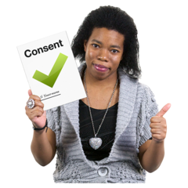  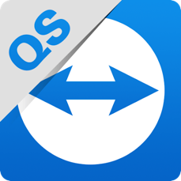 | TeamViewer is an app that means we can help you with your tablet. We can connect to the tablet to see your screen to see what is happening and help know what to do. We can only do this each time if you allow us to.
Your privacy is important to us, however we can check how you have been using the phone when we help you on TeamViewer. We will not talk to other people about your private life.
We want the tablet to be a good thing in your life.

We have a Duty of Care to everyone we give a phone to.

This means if someone is in danger of harm or we think your safety is at risk we will have to tell someone. We will try and talk to you about this first.

 | We will talk to you about the tablet after 3 months and see if it is still useful for you. You can be part of a focus group to find out about people’s experiences and learn as we go.
 | We will ask you what you think about having the tablet, what has been good and if there have been any bad things so we can learn from them.
 | Here is a list of Your Voice Counts Zoom groups so far, there might be more in the future.
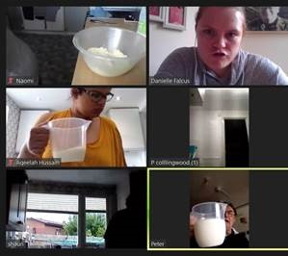 | Mondays at 12pm  Cooking with Confidence  Every 2 weeks
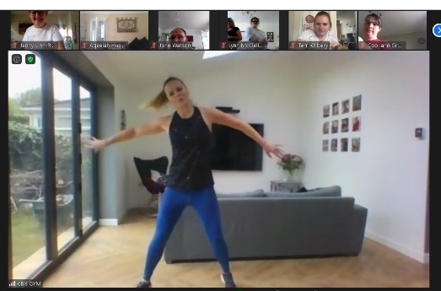 | Tuesdays at 11am  Accessible Fitness  Every week
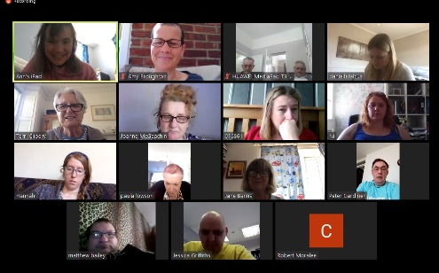 | Wednesdays at 2pm  Self-Advocacy Group  Every week
Thursdays
Men’s Group/ Women’s Group
Once a month

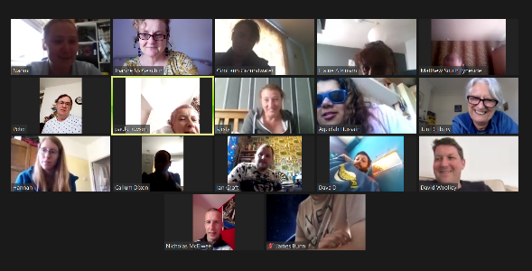 | Fridays at 2pm  Catch up and a Cuppa  Every week

I …………. have understood this information and agree to it.
Date: Signed: ………………………………..

I ………….. agree to help …..............................to manage the risks of using this device and being online.
Date: Signed: ………………………………….

WhatsApp - text and video
Skype - text and video
Email - text
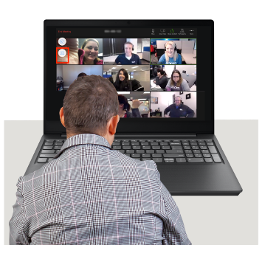 Zoom - group video calls
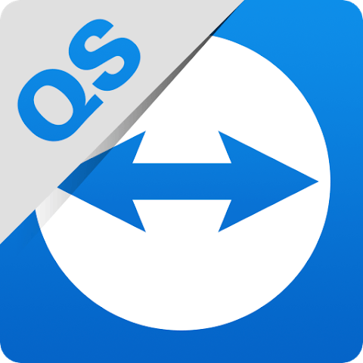 TeamViewer - Help from us when you are stuck and to learn how to do things

Important things to remember
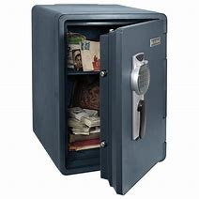 | - Keep your information safe – don’t put your address or bank details online
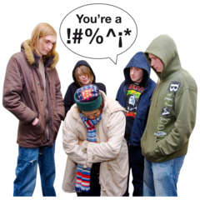 | - Keep yourself safe – people may not be who they say they are, people can be mean and nasty online
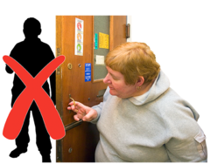 | - Don’t talk to strangers – strangers who want to be your friend can have bad reasons
 | - Know that information on the internet might not be true
 | - Don't trust free offers – they are usually not free
 | - Don’t open links unless you know who they are from
 | - Be careful who you add as a friend – they may not be kind to you
 | - Ask someone you trust to help you if you are not sure. Ask Your Voice Counts staff for help
 | - There are lots of ways to spend money on the internet. There are safe ways to do this
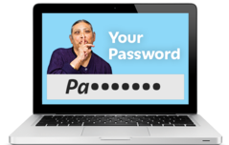 | 10. Don’t tell other people your passwords

