No: 686/19
29th November 2019

TO: ALL BRANCHES

Dear Colleague

Royal Mail Dispute Leverage Campaign – Letter to all Royal Mail Group Corporate Shareholders

The purpose of this LTB is to advise Branches that the attached letter is being sent to all major corporate shareholders of the Royal Mail Group. The letter explains that despite what has taken place in the court, the union and its members remain totally opposed to the company’s strategy for the future.

The letter also makes it clear that the blame for this dispute lies squarely at the door of the CEO and the Royal Mail Board. Furthermore, the union will invite major shareholders to a meeting where we will set out an alternative vision for the future.

In opening up this new flank in our dispute, we believe it will put significant pressure on the employer to reconsider its plans. The union will be seeking media publicity on this development and we are committed to ongoing direct engagement to leverage shareholders and ensure they respond in an appropriate way.

Engaging Members in our Leverage Campaign

It is important that you make our members aware that the union has opened up this new flank in the dispute. We will shortly be sending out further information, including details of the corporate shareholders we are targeting, and we will be asking individual members to write directly to these shareholders in support of the dispute.

Engaging the Public and Politicians in our Leverage Campaign

In order to build up the pressure, in the near future we will also be asking the wider public and politicians to take similar actions in support of our dispute.

Finally, please ensure the content of this LTB and the attached letter is widely circulated to all CWU Representatives and members and we would ask that in turn our Reps engage their managers on the actions the union will now be taking.

Any enquiries on the content of this LTB should be addressed to gsoffice@cwu.org

Yours sincerely
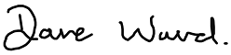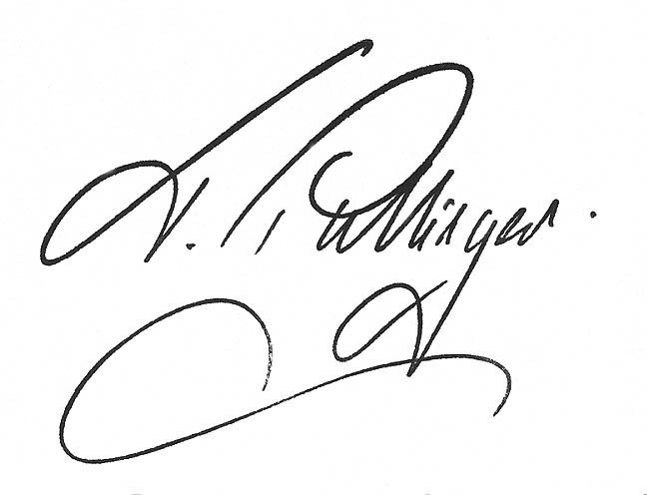
Dave Ward Terry Pullinger
General Secretary Deputy General Secretary (P)

Dear

The Communication Workers Union are writing to all major shareholders in the Royal Mail Group PLC to set out the facts behind our ongoing dispute with the company and explain our next steps.

Firstly, we must be clear that despite Royal Mail being granted an injunction to invalidate our strike ballot, the CWU and its membership will continue to do all within our power to oppose the company’s strategy to set up a separate parcels business and allow thousands upon thousands of jobs in the core business to wither on the vine.

You should be in no doubt that the CEO and his Board have totally lost the confidence of the workforce and that managers at all levels are now questioning the integrity, commitment and capability of the board to run the business.

Following the outcome of the court proceedings, the workforce are now angrier than ever and there is one simple truth that the company cannot face away from; without the support of the workforce it is impossible for Royal Mail to introduce its plan as presented to all shareholders at Capital Markets day in May 2019.

The facts behind the dispute

The blame for this dispute lays squarely at the door of the CEO and his Board.

Shortly after taking up the role, the CEO decided to walk away from two major agreements (The Four Pillars of Security and Agenda for Growth), which the company had made in good faith with the union in 2018 and 2013 respectively.

These agreements, overwhelmingly endorsed by the workforce, spelt out the overall plan and strategy on how we would jointly shape the future of the business. Instead, without any prior consultation, the CEO launched his own plan at the Capital Markets Day event. In doing this, the CEO deliberately misled shareholders by claiming the union was on board. This could not have been further from the truth. A fact totally backed up by over 97% of the workforce voting for strike action in a massive 76% turnout.

Next steps

The CWU and the workforce will continue to oppose the company’s plans for the future. We can advise you that we are now undertaking the following actions.

- We will engage in meaningful negotiations providing the company agree to set aside their plans to set up a new parcels business. To be clear, to settle this dispute the company must reinstate our agreements as the plan for the future and resolve all the issues advised of in the industrial action ballot.
- We are ready to re-ballot for industrial action if the company decides to press on regardless or we fail to reach an acceptable agreement.
- We will be organising a shareholder meeting in London in the near future and we will shortly advise you of the date and venue for this. At this meeting we will explain, in line with our agreements, the alternative vision for the future that will grow the core business, expanding the role of postal workers in local communities and businesses, as well as delivering sustainable parcel growth.
- We will be mounting a major public and political campaign to expose the shortcomings of the Royal Mail Board and gain support for our alternative vision of the future.
- We are investigating the basis upon which Royal Mail has added in October 2019, over £470 million of debt to its balance sheet. We believe the reasons for this have not been properly explained to shareholders.

In the meantime, we are asking you to write to the CEO raising the issues covered in this letter and urge the Board to cease its unilateral actions and engage in meaningful negotiations to find a mutually beneficial way forward. We are available for direct discussions with you and you can contact us on the following email address dward@cwu.org.

We will write to you soon with a date and venue for the shareholder meeting.

Yours sincerely

Dave Ward Terry Pullinger
General Secretary Deputy General Secretary (Postal)

